**SOUTHER RIVER COLLEGE**

**Human Biological Science**

**Unit 3 & 4**

**TASK 3 – Test 1**

**Endocrine & Nervous System**

**Time: 60 mins**

Multiple Choice: 15 marks

Short Answer: 25 marks

Extended Answer: 20 marks

TOTAL 60 MARKS

**Weighting: 5%**

**Do not turn page until instructed to do so**

**Section A: Multiple Choice (15 Marks)**

Answer all questions by placing an X through the most correct answer on the multiple choice answer sheet.

1. Which of the options below is the first place that is involved in the regulation of Thyroxine:

1. Hypothalamus
2. Anterior pituitary
3. Posterior pituitary
4. Thyroid

2. Which of the following choices lists only endocrine glands?

1. Pituitary, salivary gland, thyroid gland
2. Pancreas, liver, pituitary gland
3. Islets of langerhans, pituitary gland, adrenal gland
4. Parathyroid glands, adrenal glands, kidney.

3. Which of the following is FALSE about the comparison between nervous and hormonal actions of the body?

|  |  |  |
| --- | --- | --- |
|  | **Nervous Action** | **Hormonal action** |
| a) | Impulse electro chemical | Impulse chemical |
| b) | Messenger passed along nerve fibres. | Messenger passed by blood stream |
| c) | Response slow and lasting | response swift and short |
| d) | Not concerned with growth and development | Concerned with growth and development |

4. Ovulation is produced by a rise in

1. Luteinising hormone and oestrogen
2. Luteinising hormone and progesterone
3. Follicle stimulating hormone and oestrogen
4. Follicle stimulating hormone and progesterone

5. The target organ for Follicle Stimulating Hormone (FSH) is the:

1. uterine tube.
2. ovary.
3. uterus.
4. vagina.

6. Which one of the following is correct?

|  |  |  |  |
| --- | --- | --- | --- |
|  | Structure | Sympathetic  Activity | Parasympathetic Activity |
| a) | Urinary bladder | Relaxation | Contraction |
| b) | Salivary glands | Increased secretion | Reduced secretion |
| c) | Liver | Increased glucose uptake | Increased release of glucose |
| d) | Bronchioles of the lung | relaxation | Constriction |

7. Voluntary muscle movement is controlled by

1. an upper motor neuron in the brainstem and a lower motor neuron in the spinal cord.
2. an upper motor neuron in the cerebrum and a lower motor neuron in the spinal cord.
3. an upper motor neuron in the cerebrum and a lower motor neuron in the dorsal root ganglion.
4. an upper motor neuron in the spinal cord and a lower motor neuron in the skeletal muscle

8. Injury to the hypothalamus may result in all of the following EXCEPT

1. a loss of temperature control.
2. a production of excessive quantities of urine.
3. loss of awareness of body position.
4. a disrupted menstrual cycle.

9. Which of the following is NOT a function of the cerebrospinal fluid?

1. Transfer of neural messages from one part of the brain to another.
2. Aid removal of metabolic wastes and supply of nutrients to nerve tissue.
3. Suspension of the brain in fluid to reduce pressure on particular points.
4. Protection of the central nervous system from mechanical damage.

10. Which statement about nerve fibres is correct?

1. Fibres that have a larger diameter will conduct impulses slower than those with a smaller diameter.
2. Myelinated fibres conduct impulses slower than unmyelinated nerve impulses.
3. Nodes of Ranvier increase the speed of nerve impulse transmission.
4. All myelinated nerve impulses end on skeletal muscles.

11. The spinal cord has white matter

1. inside, grey matter outside.
2. outside, grey matter inside and a ventral motor root.
3. outside, grey matter inside and a dorsal motor root.
4. inside, grey matter outside and a ventral motor root.

12. The somatic division belongs to which component of the peripheral nervous system

1. Afferent
2. Autonomic
3. Efferent
4. Parasympathetic

13. Which of the following is correct?

1. Afferent division carries information into the CNS
2. Efferent division carries information away from the CNS
3. The autonomic division is responsible for preparing the body for strenuous physical activity
4. All of the above

14. If the sympathetic nerve to the heart was cut, the heart rate would be expected to:

1. increase
2. decrease
3. stay the same
4. increase then decrease

15. Looking at the picture below the synapse is labelled:

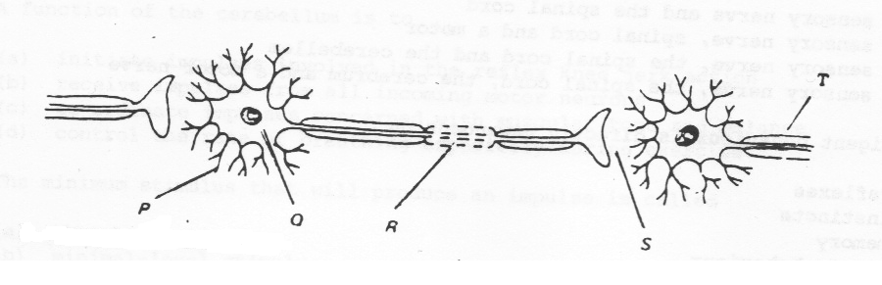

1. P
2. Q
3. R
4. S

**END OF SECTION A**

Name _________________________________________

Teacher_________________________________________

**SOUTHERN RIVER COLLEGE**

**Human Biological Science**

**Unit 3 & 4**

**TASK 3 – Test 1**

**Endocrine & Nervous System**

TOTAL 60 MARKS

**Multiple Choice Answer Booklet**

Answer all questions by placing an X through the correct answer

|  |  |  |  |  |  |  |  |  |  |  |
| --- | --- | --- | --- | --- | --- | --- | --- | --- | --- | --- |
| **1** | A | B | C | D |  | **11** | A | B | C | D |
| **2** | A | B | C | D |  | **12** | A | B | C | D |
| **3** | A | B | C | D |  | **13** | A | B | C | D |
| **4** | A | B | C | D |  | **14** | A | B | C | D |
| **5** | A | B | C | D |  | **15** | A | B | C | D |
| **6** | A | B | C | D |  |  |  |  |  |  |
| **7** | A | B | C | D |  |  |  |  |  |  |
| **8** | A | B | C | D |  |  |  |  |  |  |
| **9** | A | B | C | D |  |  |  |  |  |  |
| **10** | A | B | C | D |  |  |  |  |  |  |

**Section B: Short Answer (25 Marks)**

Answer all questions in the spaces provided.

**Question 1 (6 Marks)**

The diagram below refers to parts (a) through (c) of question 1

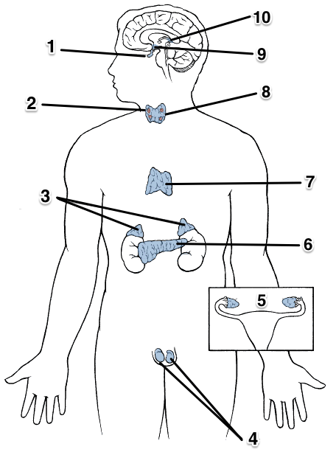

a) How does structure 1 have an effect on the release of hormones from structure 3?

(2 marks)

________________________________________________________________

________________________________________________________________

________________________________________________________________

b) What impact does structure 9 have on the endocrine system? In your answer use an example.

(2 marks)

________________________________________________________________________________________________________________________________

________________________________________________________________

c) If structure 6 was badly damaged, the production of which hormones would be reduced?

(2 marks)

________________________________________________________________

**Question 2 (4 Marks)**

A boy was asked to speak, on behalf of the student body, at his year 12 Graduation ceremony. Prior to his speech, he felt extremely nervous.

1. Which **specific** part of his nervous system would have contributed to his condition?

(1 mark)

_____________________________________________________________

1. What hormone would have been involved in this process?

(1 mark)

_____________________________________________________________

1. From where was this hormone released?

(1 mark) _____________________________________________________________

1. Compare the actions of nerves and hormones in regard to the specificity of their actions.

(1 mark) _____________________________________________________________

_____________________________________________________________

**Question 3 (3 marks)**



A B C

A B C

A B C

a) What do the different bands labelled A B C represent?

(3 marks)

A ______________________________________________________________

________________________________________________________________

B ______________________________________________________________

________________________________________________________________

C ______________________________________________________________

________________________________________________________________

**Question 4 (4 marks)**

**Picture A**

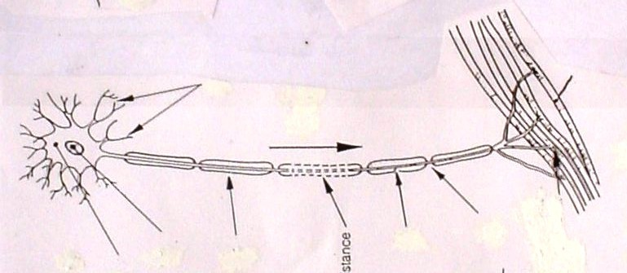

b) Classify the neuron in picture A according to its structure and function.

(2 marks)

Structure

________________________________________________________________

Function

________________________________________________________________

c) This type of neuron can transmit an electrical impulse up to 140metres/second. Can you explain the reasons why the impulse is able to travel at this speed?

(2 marks)

________________________________________________________________

________________________________________________________________

________________________________________________________________

________________________________________________________________

________________________________________________________________

**Question 5 (8 marks)**

Complete the table below to show the site of production, hormone produced, target organs and effect of the hormones associated with various endocrine glands in the human body.

(8 marks)

|  |  |  |  |
| --- | --- | --- | --- |
| **Production site** | **Hormone produced** | **Target organ/s** | **Effect** |
| Anterior Pituitary |  | Breast Tissue |  |
|  |  | Liver |  |
|  |  | T-Lymphocytes |  |

**END OF SECTION B**

**Question 1**

**Section C: Extended Answer (20 Marks)**

Answer all parts of ALL questions on the lines provided.

Fiona, a very excitable young girl, was walking along a busy street talking intensely on her mobile phone to her best friend. She was so focused on her conversation that, without thinking, she stepped onto the road and was immediately startled by the screeching of tyres and the blaring sound of a very loud horn. When she realised that she had stepped in front of a car but had not been run over, she felt greatly relieved but noticed that her body had responded in several different ways.

1. Identify the responses that Fiona’s body would automatically demonstrate in her reaction to danger and explain how each is useful in this situation.

(6 marks)

Fiona is now afraid and refuses to cross roads without her mother there to hold her hand. The hormone cortisol has been released in her body in response to this stress.

1. Cortisol is a steroid hormone. Describe how this hormone acts upon a cell. (3 marks)

**AND**

**Question 2**

The Chemical Weapons Convention was agreed upon in 1997 which prevents the use of chemical weapons to deliberately harm another person. Today, 192 countries are under this treaty which is now international law.

On March 4, former Russian spy Sergei Skripal, his daughter Yulia were exposed to Novichok (a nerve agent) in England. This nerve agent acts to inhibit the enzyme which breaks down neurotransmitters at synapses in the cental and peripheral nervous systems.

1. What happens when a neurotransmitter is not removed from the synapse?
2. marks)
3. Using the somatic nervous system as an example, describe how a nerve impulse travels across a synapse to the effector.
4. marks)
5. Action potentials are described as ‘all or none responses’. However, it is possible for you to detect the difference between a sheet of paper and a brick being dropped on your foot. Explain why.

(3 marks)

________________________________________________________________

________________________________________________________________

________________________________________________________________

________________________________________________________________

________________________________________________________________

________________________________________________________________

________________________________________________________________

________________________________________________________________

________________________________________________________________

________________________________________________________________

________________________________________________________________

________________________________________________________________

________________________________________________________________

________________________________________________________________

________________________________________________________________

________________________________________________________________

________________________________________________________________

________________________________________________________________

________________________________________________________________

________________________________________________________________

________________________________________________________________

________________________________________________________________

________________________________________________________________

________________________________________________________________

________________________________________________________________

________________________________________________________________

________________________________________________________________

________________________________________________________________

________________________________________________________________

________________________________________________________________

________________________________________________________________

________________________________________________________________

________________________________________________________________

________________________________________________________________

________________________________________________________________

________________________________________________________________

________________________________________________________________

________________________________________________________________

________________________________________________________________

________________________________________________________________

________________________________________________________________

________________________________________________________________

________________________________________________________________

________________________________________________________________

________________________________________________________________

________________________________________________________________

________________________________________________________________

________________________________________________________________

________________________________________________________________

________________________________________________________________

________________________________________________________________

________________________________________________________________

________________________________________________________________

________________________________________________________________

________________________________________________________________

________________________________________________________________

________________________________________________________________

________________________________________________________________

________________________________________________________________

________________________________________________________________

________________________________________________________________

________________________________________________________________

________________________________________________________________

________________________________________________________________

________________________________________________________________

________________________________________________________________

________________________________________________________________

________________________________________________________________

________________________________________________________________

________________________________________________________________

________________________________________________________________

________________________________________________________________

________________________________________________________________

________________________________________________________________

________________________________________________________________

________________________________________________________________

________________________________________________________________

________________________________________________________________

________________________________________________________________

________________________________________________________________

________________________________________________________________

________________________________________________________________

________________________________________________________________

________________________________________________________________

________________________________________________________________

________________________________________________________________